Physics Society

Org description: The Physics Society’s members comprise of mostly Physics Majors, Engineering students, and physics enthusiasts among the Lasallian community. We conduct activities include, though not limited to, field trips, leadership training, and activities that aim to encourage students to appreciate physics in their everyday lives.

Vision-Mission

To encourage interest in Physics and its application towards its members in a fruitful sharing of ideas in genuine pursuit of knowledge towards the holistic growth of each member in the spirit of the university’s vision and mission.

Logo

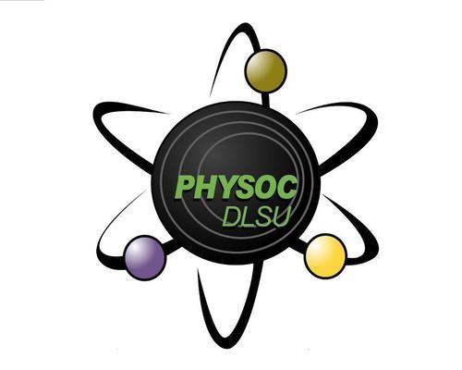

Activities

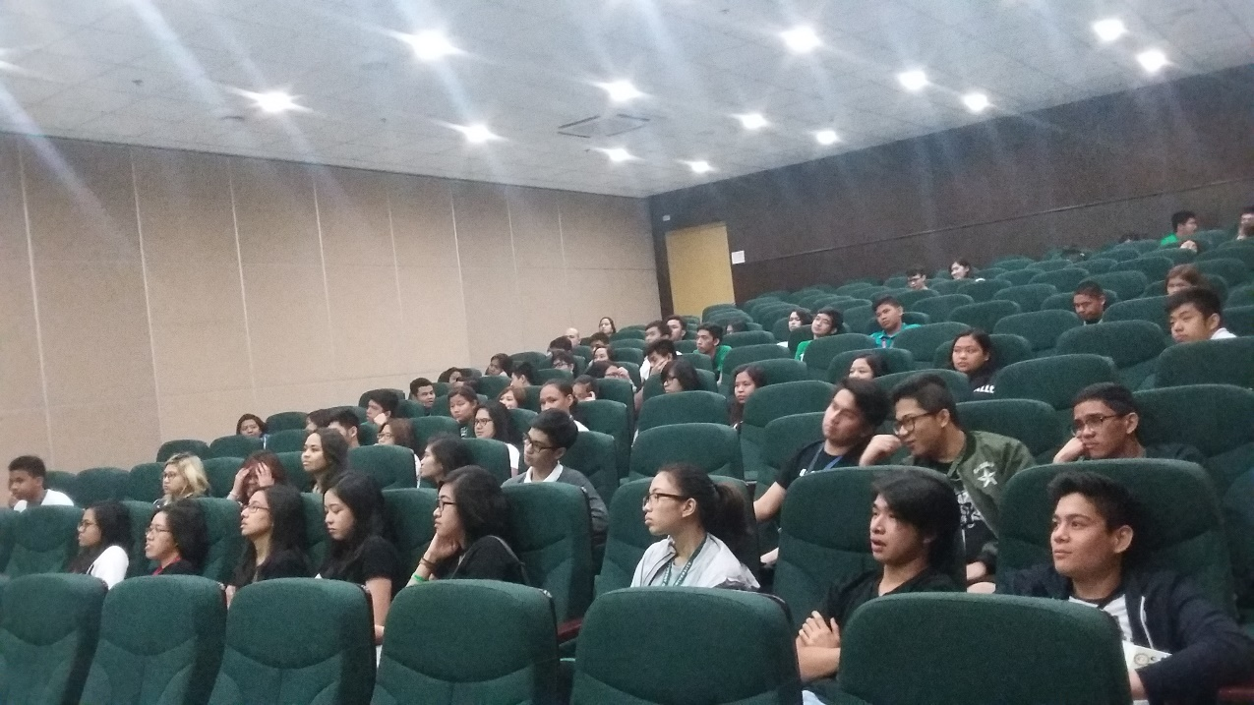

Conducted a field trip to DLS-HIS

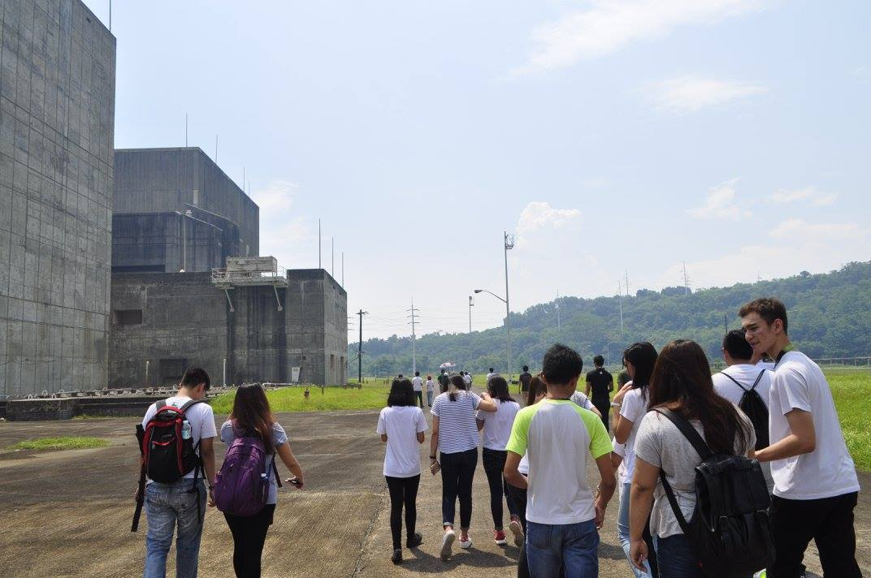

Conducted a field trip to Bataan Nuclear Power Plant

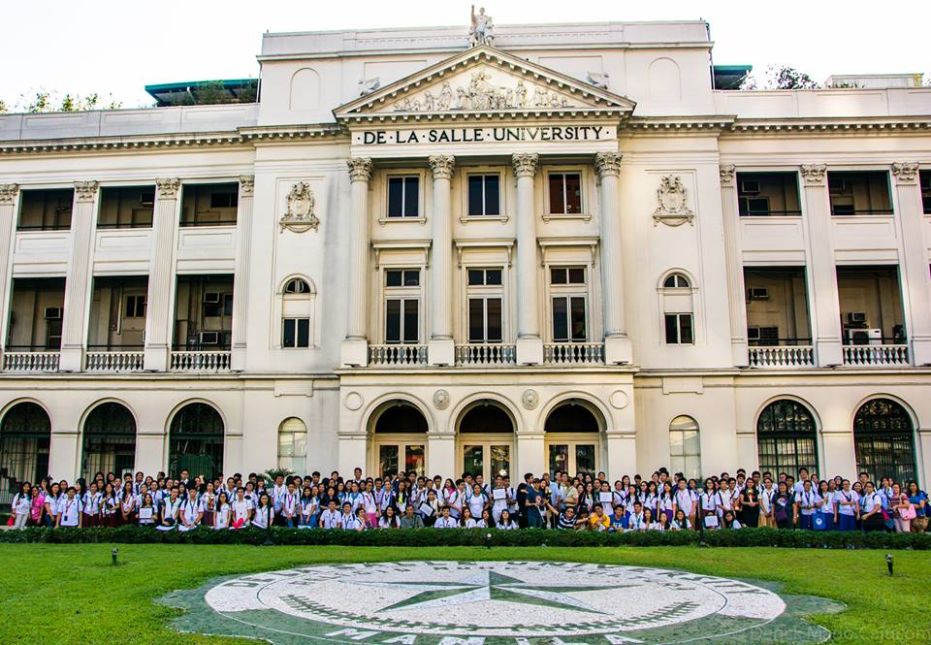

Hosted the opening of the National Astronomy Week 2016 in partnership with Philippine Astronomical Society.